Justification:
The primary goal of this project is to create a healthcare records management system for potential further use with stroke prediction (using dummy data), in a python-flask web app. In order to achieve the desired outcomes, careful planning, and “Secure Software Development Life Cycle” (SSDLC) best practices and industry standards will need to be followed with ethical considerations of data protection for patient’s records, in-line with the relevant regulatory standards.
The NHS England website includes multiple documents for legal, technical implementation and handling of sensitive medical data including a guide and specification (NHS England, 2025). Key takeaways that are relevant to this project are the requirements to comply with “General Data Protection Regulations” (GDPR), the data protection act 2018 and/or ISO 27001 (“where this standard is of an equivalent or higher level than the DSPT” (NHS England, 2025)), and maintaining auditing documentation.
When it comes to security the "Open Worldwide Application Security Project's" (OWASP) provides a number of useful resources including penetration testing tools and general software application standard specification guide. OWASP is a non-profit that specialises in application security, whose standards have been adopted and recommended by many successful businesses and institutions such as Amazon, Sales Force and Microsoft (OWASP, 2025) (landbase, 2025).
This project will focus on OWASP’s “Application Security Verification Standard” (ASVS) (OWASP, 2025) for security design, which will help afford high assurance that the project maintains wide defence coverage across as many attack vectors as is feasible. In version 5 of the ASVS document there are 17 different categories or areas of concern that will need to be designed for (OWASP, 2025).
The following finalised specification aims to best achieve as many, and most impactful elements of the previously discussed requirements while remaining mindful of the scope, resources and development time available.
Specifications:
Functionality:
- Well designed and user friendly home, login, registration, user settings, dashboard and individual records CRUD management pages.
- At least two roles, one for users and administrators, where admins have access to tools for overall records analysis and searches, and users are only able to CRUD their own records and delete their account and associated data if desired.
Data Protection and compliance:
- Limit data collection to only the necessarily required data for the needs of record analysis and website functionality.
- Comprehensive activity logging, for accountability.
- Secure retention and deletion procedures, ensure no third parties are able to access sensitive data with fail safety contingencies.
- Use separate databases for user data, administrator user data, patient records and their respective audit logs, with encryptions at rest and for in transit for any sensitive data such as patient record ID’s, while maintaining search ability.
Security:
- Encoding & Sanitization: Use “Bleach” and “Flask-Talisman” to clean and sanitise user inputs.
- Validation & Business Logic: Use data validation on database CRUD (Create, Read, Update and Delete) operations to assure data is correctly typed and formatted safely.
- Web Frontend Security: Use “Flask-WTF” for “Cross-Site Request Forgery” (CSRF) protection and cookie tokens, and “Bleach” again for “Cross-Site Scripting” (XSS) protection.
- API & Web Service: Use “Flask Login” for secure session management and “limiter” for rate limiting.
- Authentication: Use “cryptography” and “Flash-Bcrypt” for strong password hashing and encryption.
- Authorisation: Create an elevated privilege role for an administrator, complete with audit logging.
- Self‑contained Tokens: Use “Hash-Based Message Authentication Code” (HMAC), for deterministic “one-way” search ability.
- OAuth & OIDC: Use separated servers for resources, users and administrators along with their respective audit logging.
- Cryptography: Covered with “cryptography”, use authenticated cryptography with fail safe on startup.
- Configuration: Use HTTPS with self-certifications or free certifications, and avoid using insecure HTTP connections,
- Data Protection: Use encryption at rest and in transit for all sensitive data to be stored on the databases.
- Secure Coding & Architecture: Perform threat modelling when appropriate and use “defensive coding” when possible.
- Security Logging & Error Handling: Use Secure logging, and audit.

Testing:
- Implement “Static Application Security Testing” (SAST) procedures, analysis the source code before deployment. Using tools such as ”bandit” or “semgrep” to check libraries for vulnerabilities or code for security mistakes.
- Implement “Dynamic Application Security Testing” (DAST) procedures, for catching runtime issues such as authentication flaws, poor server configurations and XSS/CSRF exploits, with tools such as “OSWAP ZAP”.
- Include comprehensive unit testing coverage and use github build tests with github actions if possible.

Design Methodology:
There are a number of different approaches to SSDLC’s planning and design stages (atlassian, 2025) (jFrog, 2025), this project will skew more towards a hybrid approach reminiscent of agile or DevOps. Using an iterative and testing focused methodology ensures issues in every stage are caught early and if necessary, changes implemented to best meet the specifications without lengthy process changes later stages.
An overview of the process is: Planning (requirements and specifications) -> Design -> Threat modelling (such as STRIDE) -> implementation -> Testing -> deployment and maintenance.
Design:
As per the specifications, page mock ups were created for guidance on style, page formatting and deciding on how the UX/UI of the site should flow. In order; Home page, Login page, Registration Page, Account Page, Users Dashboard Page and Administrators Dashboard Page.
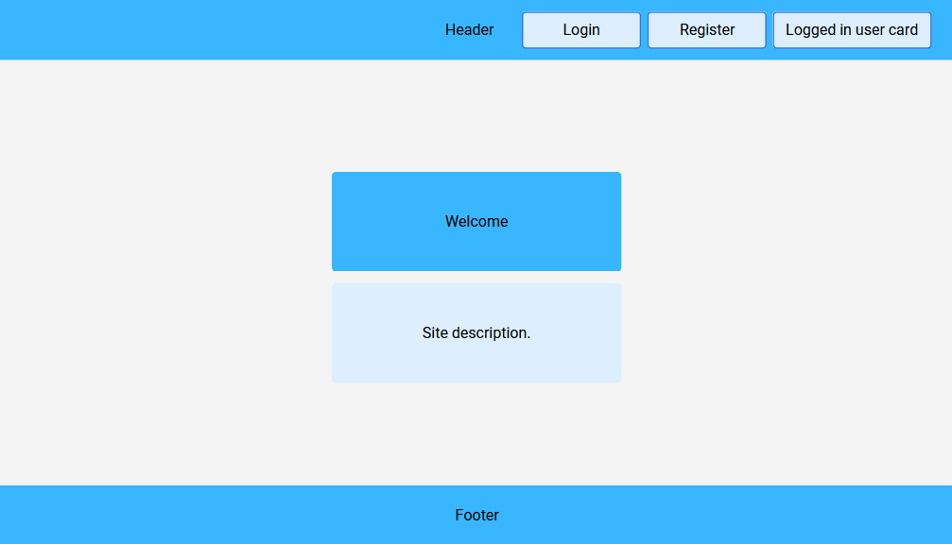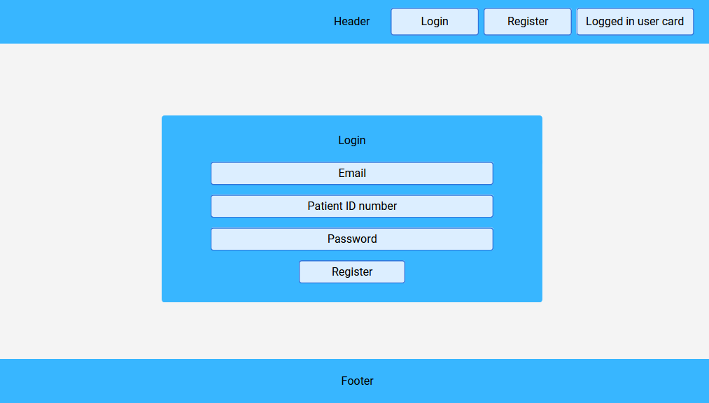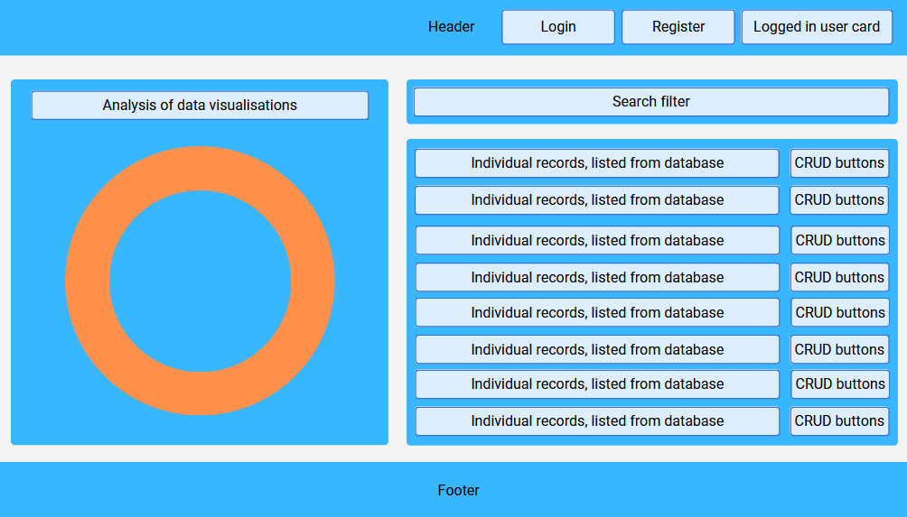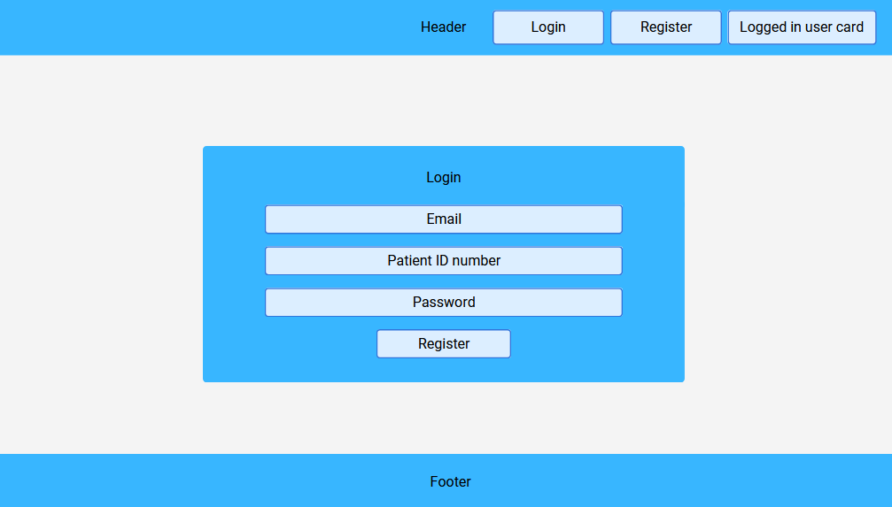

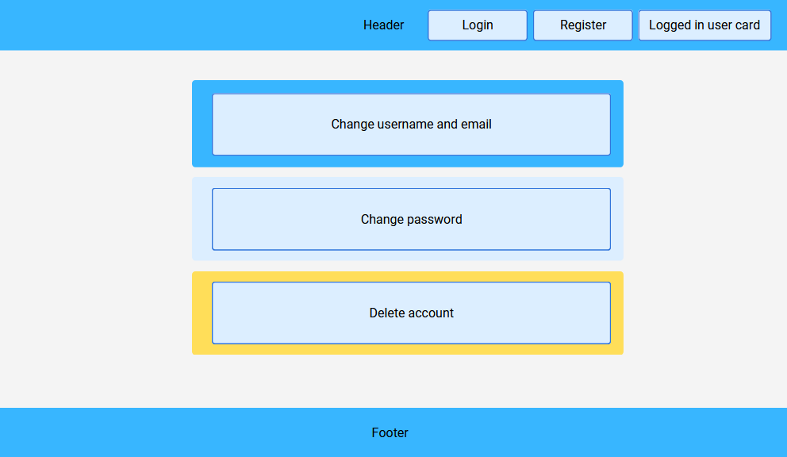

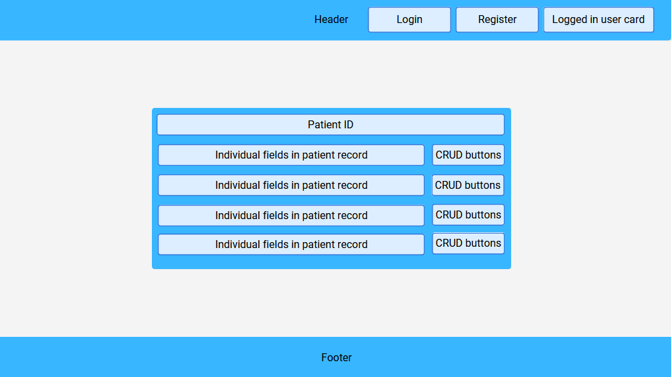

Database Schema:
The proposed Database schema for the project:
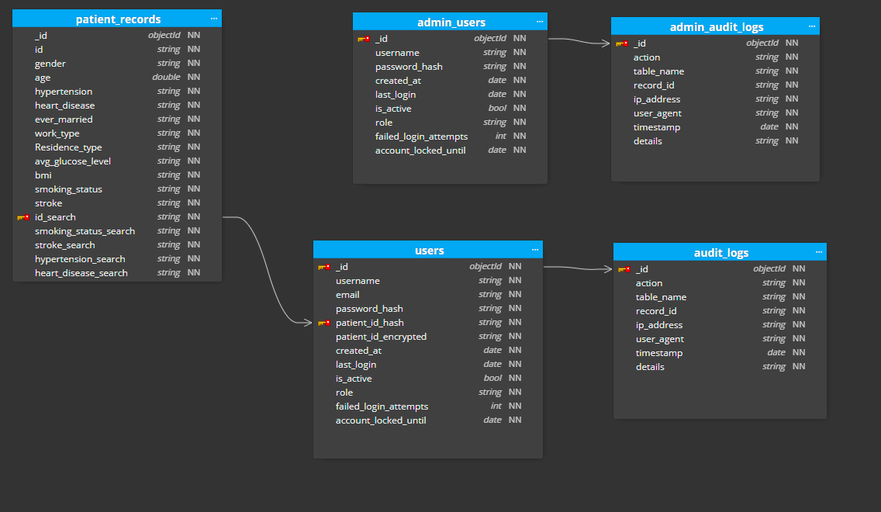

STRIDE Threat Model:
According to OWASP’s advice for threat modelling using “Spoofing, Tampering, Repudiation, Information disclosure, Denial of service and Elevation of privileges” (STRIDE). There are four steps to this analysis, scope the work, determine threats, and determine countermeasure/mitigations and then assessing the work (OWASP, 2025). As part of determining the scope of the project, in its relation to STRIDE, we will look at entry points and assets.
Entry Points:
ID | Name | Description | Trust Levels
1 | HTTPS port | Public TLS endpoint for all web traffic, gateway for the site page. | 1,2,4
2 | Homepage | Public splash page. | 1,2
3 | Registration page | Signup data collection with minimally required data. | 1,2
4 | Registration function | Server processing for signup validation and storing users. | 1,2
6 | Login page and function | Authentication process, verify credentials and handle sessions and tokens. | 2,3,4
7 | Search entry | Search and filter records as admin, using deterministic HMAC indexes. | 2,4
8 | Dashboard / CRUD Operations | User CRUD operations for patient records (create, read, update, delete). | 2,4
10 | Account settings and deletion | Manage profile and request data deletion. | 2

Assets:
ID | Name | Description | Trust Levels
A1 | User accounts. | Authentication credentials and profile metadata. | 2,4,5
A2 | Patient records. | All patient personal and medical data stored in the records database. | 2,4,5
A3 | User database. | Authentication and user database separation from the records database. | 5
A4 | Admin database. | Administrator user data and admin-only indexes. | 5
A5 | Audit logs. | Audit events for access and action to remain traceable. | 4,5
A7 | Encryption keys. | Master keys, HMAC keys, key materials must be protected. | 6
A8 | Session tokens and cookies. | Active session identifiers issued at login. | 2,4
A9 | Search Indexes / HMAC tokens. | Deterministic hashes used to enable search. | 2,4,5

This describes the trust levels with their corresponding numeration, indicating the level of access required for entry at each point and asset respectively (OWASP, 2025).
Trust Levels:
ID | Name | Description
1 | Anonymous web user. | Not authenticated, public access only.
2 | Authenticated user. | Regular user with access to their own records.
3 | Invalid credentials. | Unsuccessful authentication attempts or attacker with credentials invalid.
4 | Administrator. | Elevated role with cross-record search.
5 | System database. | Database server and internal system processes.
6 | Key management service. | KMS / vault service identity and access role.
7 | Web server process. | Process identity used by app to access database services.
8 | Database read user. | Database account with read-only access.
9 | Database read/write user. | Database account with read/write capability.

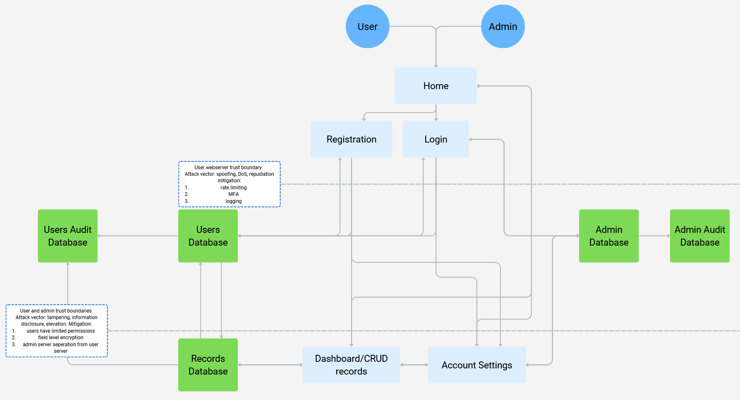Next, Data flow diagrams (DFD) can be helpful for visualise and model the applications data flows, helping us identify critical components. Weak points and flow control (OWASP, 2025).
DFD:

STRIDE Threat List:
Type | Description | Security Control
Spoofing | Credential stuffing / account takeover at login. | MFA, rate limiting, account lockout.
Tampering | Insecure direct object reference (IDOR) allowing other users’ record edits. | Server-side object-level authorization, negative authentication tests.
Repudiation | Missing or tamper able authentication/audit logs. | Append-only immutable logs, signed timestamps and ACLs.
Information Disclosure | “Protected Health Information” (PHI) exposure via database compromise or weak TLS. | TLS strong cipher policy, encryption at rest, data minimisation.
Denial of Service | DoS on HTTPS port or authentication endpoint (flooding). | Rate limiting, throttling, CAPTCHA for suspicious traffic.
Elevation of Privilege | Admin account compromise granting full dataset access. | Separate admin credentials, hardware MFA, least privilege.
Information Disclosure | Deterministic HMAC search tokens enabling linkage/re-identification. | Per-field salts, key rotation, restrict search API.
Tampering | Direct database modification via compromised database credentials. | Network segmentation, limited privileged accounts, database auditing.
Repudiation | Account deletion not propagated to backups (no proof of deletion). | Documented deletion workflow, tested backup purge/overwrites.
Spoofing | API keys or secrets stored in configuration/repo (key leakage). | Remove secrets from repo, rotate keys, CI secret scanning.
Tampering | Cross-site scripting (XSS) enabling session theft. | Bleach with explicit allow list, output escaping, CSP via Flask-Talisman.
Denial of Service | Search API abuse (heavy/expensive queries) impacting database | Query caps, pagination, rate limits, expensive-query guards.
Elevation of Privilege | SQL injection and unsafe deserialization. | Parameterized queries, input sanitisation.
Information Disclosure | PHI appearing in logs or error messages. | Encrypt or exclude PHI in logs, sanitized error responses.
Repudiation / Tampering | Admin modifying audit DB to hide activity. | External immutable audit store, separation of duties, signed logs.
Spoofing / Tampering | Compromised web server process identity leading to wider access. | Harden host, least-privileged process user.

Works Cited
atlassian. (2025). https://www.atlassian.com/agile/software-development/sdlc. Retrieved from https://www.atlassian.com/: https://www.atlassian.com/agile/software-development/sdlc
jFrog. (2025). https://jfrog.com/learn/devsecops/ssdlc-secure-software-development-lifecycle/. Retrieved from https://jfrog.com/: https://jfrog.com/learn/devsecops/ssdlc-secure-software-development-lifecycle/
landbase. (2025). https://data.landbase.com/technology/owasp/. Retrieved from https://data.landbase.com: https://data.landbase.com/technology/owasp/
NHS England. (2025, August). https://digital.nhs.uk/data-and-information/information-standards/governance/latest-activity/standards-and-collections/dapb0086-data-security-and-protection-toolkit. Retrieved from https://digital.nhs.uk/: https://digital.nhs.uk/binaries/content/assets/website-assets/data-and-information/information-standards/standards-and-collections/dapb0086-data-security-and-protection-toolkit/dapb0086/0086_v8_2025_08_2025_reqspec.pdf
OpenAI. (2025). https://openai.com/index/gpt-4-1/. Retrieved from https://openai.com: https://openai.com/index/gpt-4-1/
OWASP. (2025). https://owasp.org/supporters/list. Retrieved from https://owasp.org/: https://owasp.org/supporters/list
OWASP. (2025). https://owasp.org/www-community/Threat_Modeling_Process. Retrieved from https://owasp.org: https://owasp.org/www-community/Threat_Modeling_Process
OWASP. (2025, May). https://owasp.org/www-project-application-security-verification-standard/. Retrieved from https://owasp.org: https://github.com/OWASP/ASVS/raw/v5.0.0/5.0/OWASP_Application_Security_Verification_Standard_5.0.0_en.pdf

AI declaration:
Github copilot was used for portions of the planning, research, feedback and editing of the software artefact. Mostly utilised for syntax, logic and error checking with ChatGPT and Claude Sonnet 4.5 used as the models.

